

Capstone Project Report
Report 5 – Software Test Documentation

– Ho Chi Minh City, November 2026 –
Table of Contents
I. Record of Changes 4
II. Testing Documentation 5
1. Scope of Testing 5
2. Test Strategy 8
2.1 Testing Types 8
2.2 Test Levels 8
2.3 Supporting Tools 9
3. Test Plan 9
3.1 Human Resources 9
3.2 Test Environment 9
3.3 Test Milestones 10
4. Test Cases 10

List of Figures
Figure 4.1: Unit test case 11
Figure 4.2: Test Statistic 12

List of Tables
Table 1: Scope of Testing 5
Table 2.1: Testing Types 8
Table 2.2: Test Levels 8
Table 2.3: Supporting Tools 9
Table 3.1: Human Resources 9
Table 3.2: Test Environment 9
Table 3.3: Test Milestones 10

I. Record of Changes
Date | A*  M, D | In charge | Change Description
09/11/2026 | A | Trương Nguyễn Thái Bình (SE182370) | Initial software test documentation: scope of testing, test strategy, test plan, unit test cases (38 functions) and integration / system test cases (45 modules) with their statistics.

*A - Added M - Modified D - Deleted

II. Testing Documentation

1. Scope of Testing
Table 1: Scope of Testing
Feature | Function | Role | Description
Authentication | Sign Up | Guest | Ensure the guest can create a CUSTOMER account with valid information or by phone OTP, and the system shows an error for invalid inputs.
Authentication | Sign In with Password | All Roles | Check that the user can sign in with email / phone and password and is taken to the home page of the account's role.
Authentication | Sign In with Phone OTP or Google | Guest, Customer | Ensure the Firebase phone OTP and Google sign-in are verified on the server and wrong codes are rejected.
Authentication | Sign In with Email OTP | All Roles | Ensure the 6-digit email OTP is accepted when correct and rejected when wrong or expired (300 s).
Authentication | Reset Password | All Roles | Test the password-reset flow: request the OTP by email, verify it and set a new password.
Authentication | Admin Login with 2FA | Admin | Ensure the admin needs the password and the email OTP, and the session is closed after 5 wrong OTPs.
Authentication | Log in to Kiosk by QR | Customer | Ensure the customer can scan the kiosk QR (valid 2 minutes) and confirm, and expired or reused sessions are refused.
Profile Management | Update Profile | All Roles | Ensure all users can update their personal information and avatar.
Profile Management | Change Password | All Roles | Verify a registered user can change the password and the other sessions are revoked.
Profile Management | Delete Account | Customer | Ensure the account is deleted, its email / phone are released and it can no longer sign in.
Store & Locker Search | Search Stores and Lockers | Guest, Customer | Ensure users can search stores and lockers on the list and the map with online status and free boxes.
Store & Locker Search | View Locker Box Map | Customer | Check that the real box layout shows the state of every box and only free boxes can be booked.
Locker Send | Send Parcel | Customer | Ensure the customer can create a SEND order with receiver, voucher and points, and the box is held until payment.
Locker Send | Drop Parcel and Share Pickup Code | Customer | Ensure the sender can open the paid box, confirm the drop and share the pickup code; the receiver receives the code.
Locker Send | Change PIN and Delegate Pickup | Customer | Ensure the sender can regenerate the PIN or delegate the pickup and the old PIN stops working.
Locker Send | Pick Up Parcel at Kiosk | Receiver | Ensure the receiver opens the box with the PIN or QR, and the box is locked after 5 wrong attempts.
Locker Rental | Rent Locker | Customer | Ensure the customer can rent a box by the hour, pay and reopen it with the rental PIN.
Locker Rental | Extend and End Rental | Customer | Ensure the customer can extend a rental (only the difference is charged) and end it.
Locker Rental | Pay Overdue Fee | Customer, Receiver | Ensure the box opens only after the overtime fee is paid and overdue orders expire after 72 hours.
Payment | Pay by VietQR (SePay) | Customer | Ensure the order becomes PAID only when the SePay webhook confirms the full amount, and duplicated webhooks are ignored.
Payment | Pay with Loyalty Points | Customer | Ensure point redemption follows the limits (at least 1,000 points, at most 50 % of the order) and the rest is paid by VietQR.
Payment | Request Refund | Customer | Ensure the customer can request a refund within 7 days with a reason and follow its status.
Order Management | View My Orders and Incoming Orders | Customer, Receiver | Ensure the customer and the receiver see only their own orders with status history and payments.
Order Management | Rate Order and Send Complaint | Customer | Ensure the customer can rate a completed order once or send a complaint and receive the admin reply.
Promotion & Loyalty | Save and Apply Vouchers | Customer | Ensure vouchers can be saved, applied with their scope and minimum amount, and exchanged for points.
Promotion & Loyalty | Earn Loyalty Points | Customer | Ensure completed orders earn 10 % as points, tiers follow lifetime points and points are reversed on refund.
Incident Report | Report Locker Incident | Customer | Ensure the customer can report a faulty box with title and photos and the box becomes PENDING_CHECK.
Drone Delivery | Book Drone Delivery | Customer | Ensure booking checks the receiver locker, weight (<= 5,000 g), distance (<= 5 km), weather and calculates the fee by weight.
Drone Delivery | Track Drone Delivery | Customer, Receiver | Ensure the customer sees every stage, the live position and can cancel only while awaiting dispatch.
Drone Delivery | Drone Home Pickup | Customer, Drone Technician | Ensure the pickup is offered to the nearest technician on duty and fails with a refund when not served in time.
Drone Operation | Dispatch and Confirm Loading | Drone Technician | Ensure the technician accepts an order with an idle drone (battery >= 20 %) and confirms weight, seal code and checklist.
Drone Operation | Launch and Report Flight Failure | Drone Technician | Ensure launch respects flight hours and suspensions, and a failed flight puts the order in refund.
Drone Operation | Manage Drone Fleet | Drone Technician | Ensure the technician can claim drones, change status with reason and update battery and maintenance notes.
Maintenance | Manage Shift | Locker Technician, Drone Technician | Ensure only technicians on shift with location on receive tickets, offers and missions.
Maintenance | Handle Incident Ticket | Locker Technician | Ensure the technician can claim, extend the SLA (max 2 x 24 h), return and resolve tickets with photos.
Maintenance | Perform Periodic Inspection | Locker Technician | Ensure passing all items advances the due date and a failed item opens a ticket automatically.
Maintenance | Emergency Open and IoT Devices | Locker Technician | Ensure the technician can open boxes, control the lid and restart controllers only of assigned lockers.
Administration | View Dashboard and Revenue Report | Admin | Check that the dashboard and the revenue report use the money actually collected and refunds are deducted.
Administration | Manage Accounts | Admin | Ensure the admin can search users, create staff, lock / unlock and delete accounts.
Administration | Manage Stores, Lockers and Boxes | Admin | Test CRUD of stores, lockers and boxes, batch creation and that occupied boxes cannot be deleted.
Administration | Manage Drones and Drop Incidents | Admin | Ensure the admin can register drones and decide free redelivery or compensation for dropped parcels.
Administration | Process Refunds | Admin | Ensure the admin approves with a transfer receipt or rejects with a reason.
Administration | Manage Promotions and Loyalty Rules | Admin | Ensure the admin can create promotions with period, usage limit, locker scope and point price.
Administration | Configure Business Settings and Jobs | Admin | Ensure business rules can be changed without restart, are audited, and scheduled jobs can be run on demand.
Notification | Receive Notifications | All Roles | Ensure push and in-app notifications are delivered in Vietnamese and only the owner can read or delete them.
AI Assistant | Ask AI Assistant | All Roles | Ensure answers cite only documents the role may read and the asker's own orders, and off-topic questions are refused.
AI Assistant | Manage Knowledge Base | Admin | Ensure uploaded documents are indexed with their allowed roles and the retrieval evaluation can be run.
IoT Locker | Open Box via Bluetooth | Customer | Ensure only granted accounts get a one-time signed token valid for 120 s to open a box over Bluetooth.
IoT Locker | Execute Cabinet Command | Locker Controller | Ensure the Pi executes open / lid / restart commands over MQTT and reports heartbeats, door states and results.

2. Test Strategy

2.1 Testing Types
Table 2.1: Testing Types
Objective | Technique | Completion criteria
Verify and validate each individual code unit (service methods, controllers, listeners) in isolation with mocked dependencies. | Unit testing | - All unit tests pass in CI on every pull request.  - Every main service class of the backend is covered by tests.
Check the requests, responses and error codes exchanged through the REST API, the API gateway rules and the MQTT / STOMP message contracts. | Interface testing | - Requests and responses match the API contract (status codes, error codes, payload fields).
Check correct interaction among services, the PostgreSQL databases, RabbitMQ events and the payment webhook. | Integration testing | - Data passed between services matches the expected schemas.  - Repository queries pass on a real PostgreSQL database.
Test the five business flows end to end on the deployed system with the mobile app, kiosk, admin web, cabinet and drone. | End-to-end testing | - Every test case of the test report is executed in round 1.  - No open defect blocks a business flow.
Check that the Raspberry Pi controller drives relays, door sensors and the sliding lid of the real cabinet correctly. | Hardware testing | - Every box of the cabinet opens on command and reports its door state.

2.2 Test Levels
Table 2.2: Test Levels
Type of Tests | Test Level
Type of Tests | Unit | Integration | System | Acceptance
Unit testing | X
Interface testing | X | X
Integration testing |  | X
End-to-end testing |  |  | X | X
Hardware testing |  | X | X

2.3 Supporting Tools
Table 2.3: Supporting Tools
Purpose | Tool | Vendor/In-house | Version
Unit testing (backend) | JUnit 5, Mockito, AssertJ | Open Source | JUnit 5.12.2, Mockito 5.17.0, AssertJ 3.27.7
Integration testing (database) | Testcontainers (PostgreSQL) | Open Source | 1.21.4
Build and test runner | Apache Maven, GitHub Actions | Open Source / GitHub | Maven 3.9.10
API testing | Postman / Swagger UI (springdoc) | Open Source | Latest stable
Mobile app testing | flutter_test | Google (Open Source) | Flutter 3.44
Cabinet hardware testing | Pi service panel (/service) | In-house | 1.0

3. Test Plan

3.1 Human Resources
Table 3.1: Human Resources
Worker/Doer | Role | Specific Responsibilities/Comments
Nguyễn Quốc Bảo Huy | Leader | Plan the testing, assign test functions to members, review test cases and verify test results.
Trương Nguyễn Thái Bình | Member | Write and execute the test cases of accounts, locker send / rental, payment and admin web; prepare the test report.
Lê Thị Yến Vi | Member | Write and execute the test cases of drone delivery and drone operation; write unit tests and report defects.
Trần Kim Nhã | Member | Write and execute the test cases of technicians, kiosk, IoT devices and the cabinet controller; report defects.

3.2 Test Environment
Table 3.2: Test Environment
Purpose | Tool | Provider | Version
Back-end server | Azure virtual machine + Docker Compose | Microsoft Azure | Ubuntu 24.04
Database | PostgreSQL, pgvector | PostgreSQL Global Development Group | 16
Message broker | RabbitMQ, Eclipse Mosquitto (MQTT) | Broadcom, Eclipse Foundation | RabbitMQ 3, Mosquitto 2
Admin web testing | Google Chrome | Google | Latest stable
Mobile app testing | Android phone | Google | Android 11 or later
Locker cabinet testing | Raspberry Pi 5 with kiosk touch screen | Raspberry Pi Ltd | Raspberry Pi OS (64-bit)
Unit test execution | Windows 11 PC, JDK | Microsoft, Oracle | Windows 11, JDK 21

3.3 Test Milestones
Table 3.3: Test Milestones
Milestone Task | Start Date | End Date
Unit test | 13/09/2026 | 09/11/2026
Other Test Case (IT, ST, AT) | 28/09/2026 | 07/11/2026

4. Test Cases
Unit Test Cases: Report5_Unit Test_LockR.xls
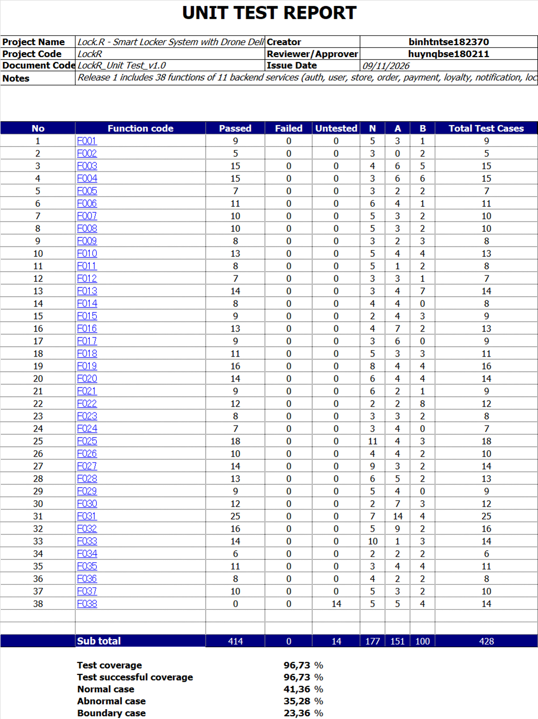
Figure 4.1: Unit test case
Test Cases and Test Reports: Report5_Test Report_LockR.xlsx
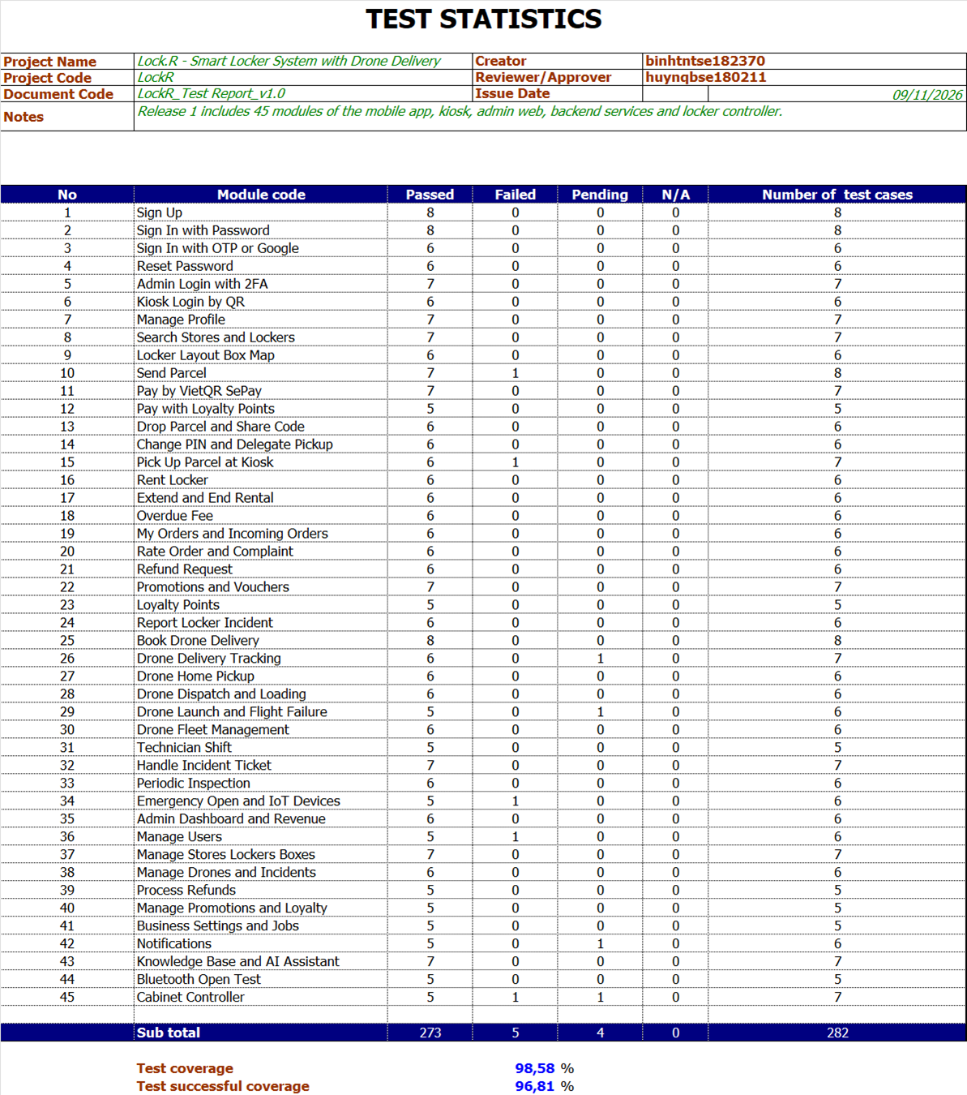
Figure 4.2: Test Statistic

